Task 1: Previous activities prior to the dissection
- Complete the table of the main structures of the Central Nervous System that are covered by the skull to get familiar with the vocabulary you are going to use.

Name in English | Name in catalan
Skull
Encephalon
Brain
Cerebellum
Medulla oblongata

Aim: Getting familiar to the anatomy of the encephalon (the brain, the cerebellum and the medulla oblongata)

Introduction

Although we are going to observe and dissect organs that you can see with the naked eye, we must first refer to the structure of the cells that compound these organs, that is, the neurons, to fully understand the colours of the organs and associate them with their functions.

As you have previously studied, the neuron is composed by the soma and the axon. The soma being the structure where we can find the dendrites and the nucleus and the axon being the structure along which the nervous impulse travels.

In the encephalon, the regions where there is an array of axons have a white colour
whilst the regions where there is an array of somas have a grey colour.

Materials
- A lamb’s encephalon
- A dissection tray
- A pair of gloves
- Scalpel handle and scalpel blades
- Scissors
- Forceps
- Curved and straight teasing needles

- Play this game https://quizlet.com/74126216/dissection-tools-flash-cards/ to get familiar with the material you are going to use and match the name of each tool with an image.

There are different interactive activities that you can do to get used to it :

  - Watch the flashcards
  - Learn
  - Write
  - Spell
  - Test

  - Match
  - Gravity
- After doing the interactive activities complete this table.

Name of the tool | Function of the tool | Image (you can search one  on the web and place it here)

Task 2: Laboratory proceeding. The dissection of the encephalon

EXTERNAL ANATOMY
- Place the encephalon in the dissection tray and try to guess where is the frontal region and where is the occipital (rear) region.
- When you are done, place two arrows on the following images with a label saying frontal region and occipital region.
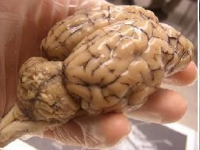
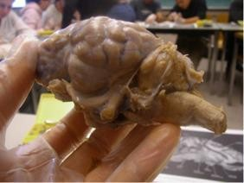
- Now, place three arrows to indicate what is the brain, what is the cerebellum and what is the medulla oblongata.

- Get an overview of the encephalon from the dorsal position.

  - Focus your attention on the brain:
- Indicate on the image below, which is the right hemisphere and which is the left hemisphere.

- Write down two reasons to explain how did you reach the conclusion

-
-

- The brain has lots of folds in its cortex, these folds are called cerebral convolutions. (indicate them on the image)
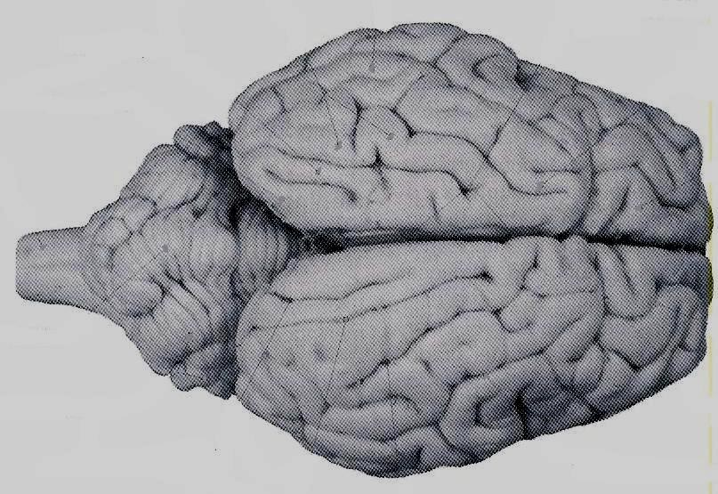

  - Now focus your attention on the cerebellum, compare what you see with the above image (that of the brain) and indicate on the below image, as well as, on the above image these structures:

Central lobe (vermis) (this one can only be seen on the image below)

Left lateral cerebellum lobe Right lateral cerebellum lobe
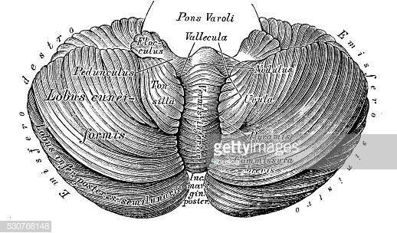

- According to what you have seen, which aspect difference do you observe between the brain and the cerebellum (complete the sentence below with the phrases provided)

Smooth look Rough look

The brain has a while the cerebellum has a

- In which of the two structures it is more clearly defined the groove between the two halves (the two hemispheres)?

  - Lateral perspective

Read the following descriptions of the four lobes of the brain and place the names on the image below.

- Frontal lobe- The one that we can see from the front.
- Parietal lobe- The one we can see along the lateral side.
- Occipital lobe- The one we can see on the back
- Temporal lobe- The one we can see close to the ear

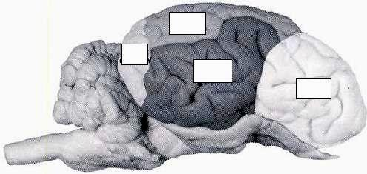

LONGITUDINAL DISSECTION OF THE ENCEPHALON

- Helping yourself with curved and/or straight teasing needles try to separate the two hemispheres of the brain (without sectioning the encephalon) until you reach the structure that links the two halves, that structure is called, the corpus callosum.

- Now make a cut along the corpus callosum with the aid of the scalpel first, and the scissors later if necessary.

- Have a look to one of the halves of the brain. Which colour is the cortex?

- What structure of the neurons can we find on the cortex according to the introduction (read again the introduction if necessary)?

- Which colour is the corpus callosum?

- What structure of the neurons can we find on the corpus callosum?

- Complete the following sketch with the vocabulary that you have learnt along the activities.

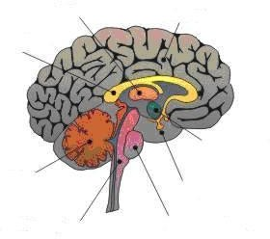

- Now focus your attention on the cerebellum. Cut it and you will observe what is called, the tree of life.
- Try to guess why does this structure receive this name.

- Which colour is the tree of life inside?

- According to this, which structure of the neurons is it formed by?

- Do the white and grey substances occupy the same position one from the other on the cerebellum than on the brain?

- Having this in mind, and knowing the function of each neuron’s structures complete the following sentences.

The main part of the brain has a colour because the main brain function is

The main part of the cerebellum has a colour because the main cerebellum function is

Finally focus your attention on the medulla oblongata.

- Which shape does it have (clue: try to guess the origin of the latin name)?

- Can you see two distinct parts on it (help yourself with this image)?

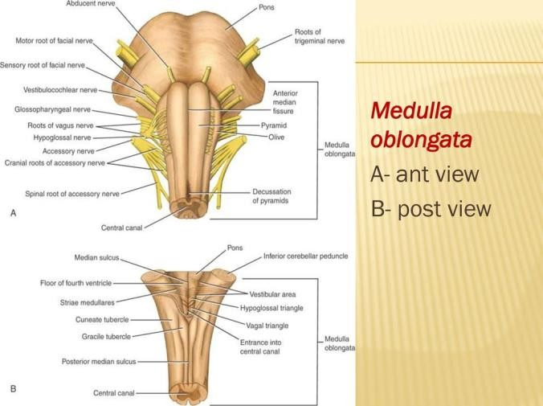

- If you see two distinct parts, are they equal?

- Where is the first and where is the second?
- To summarise the whole activity view the following video of the three parts of the brain.
https://www.thoughtco.com/anatomy-of-the-brain-cerebellum-373216 (scroll down the page to find the video).

Task 3 Getting into the nervous system and its physiology

1 Complete the table.

- Translate from Catalan to English all the structures and cell types that you have previously studied of the nervous system

- After having done that make a definition of its function

Structure or Cell type | Definition or function

Task 4 Agonists and antagonists

1 Read this text and answer the questions below

“What is an agonist?”

- An agonist is a molecule that mimics the effect of a neurotransmitter.

- The receptor is on the cell membrane of the receiving neuron .
- For example, this is the nicotinic receptor.

It does what that neurotransmitter would normally do.
  - An example of that would be
succinylcholine.
  - A molecule that mimics the neurotransmitter acetylcholine.

Have a look to the following image.
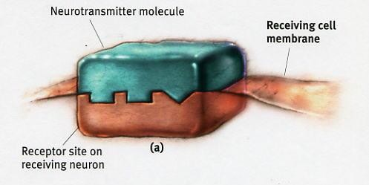

  - You can see the neurotransmitter molecule binding the receptor
Now, have a look to this image
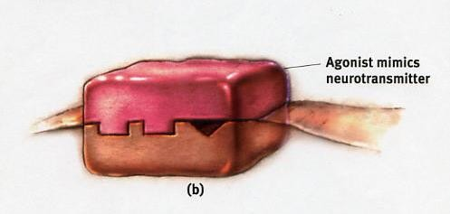

You can see an agonist.

  - It has a similar shape to acetylcholine.

This is succinylcholine.
  - When succinylcholine. binds to the receptor, the channels of sodium of the membrane cell open.

This is what they would normally do if acetylcholine had bound the receptor.
  - Then, sodium ions on the outside of the cell end up coming inside the cell.

So this would be an example of an agonist.

  - It’s not acetylcholine, it’s another molecule.
  - in this case, it’s succinylcholine.
  - That molecule binds to the receptor of the receiving neuron.
  - It causes a similar response to the one that acetylcholine would produce.

That is an agonist.

Now, have a look to this image
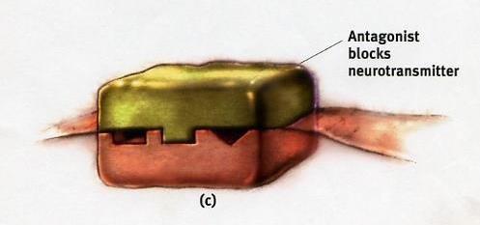

You can see an antagonist.

  - An antagonist is a molecule that opposes the effect of a neurotransmitter.

It does the exact opposite effect of an agonist.
  - An example of that would be
curare.
  - Curare is an antagonist to the neurotransmitter acetylcholine.
  - Curare can actually block the binding sites for acetylcholine in the receiving cell.
  - So when acetylcholine wants to bind the receptor, it cannot.
  - So the cannel for sodium isn’t going to open.
  - This would be an example of what curare does.
  - It is an antagonist, so curare can cause muscles to become paralyzed.
  - Curare does so because the receptors of the receiving cell cannot be activated.
  - Consequently, sodium cannot enter into the cell, exciting it and causing the muscle to contract

To finish this explanation, have a look to this image

Compare the effects of an agonist and an antagonist.

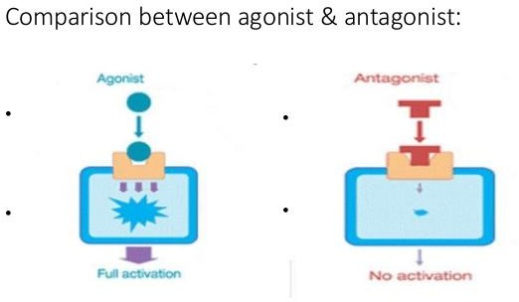

2 Let’s do some basic vocabulary first. After having read the text try to guess the meaning of these words, by matching the words on the left with the definitions on the right.

Agonist Space that separates one neuron from

another

Antagonist Cell that releases neurotransmitters

Neuron Structure of the membrane of the cell

that receives the information

Neurotransmitter Molecule that prevents the neurotransmitter from binding the receptor and thus reduces the signal transmission along the neural web
Receptor Cell of the nervous system

Presynaptic cell Molecule that imitates a

neurotransmitter and produces a similar effect on the postsynaptic cell

Synaptic space Cell that receives the

neurotransmitter and begins a new signal inside its axon

Postsynaptic cell Molecule that gives continuity to the signal from one cell to another

3 Complete the table, after having read twice the text above.

Type of substance | Function on the nervous system
Acetylcholine
Channels of sodium
Nicotinic receptor
Succynilcholine
Curare

