Task 5 The four lobes of the cerebrum and their functions
1 Before reading anything else, try to make a definition of what is the cerebrum completing this sentence
The cerebrum is, one part of the nervous system which is in charge of _________
2 Look at the following image and review what you wrote in your original sentence:
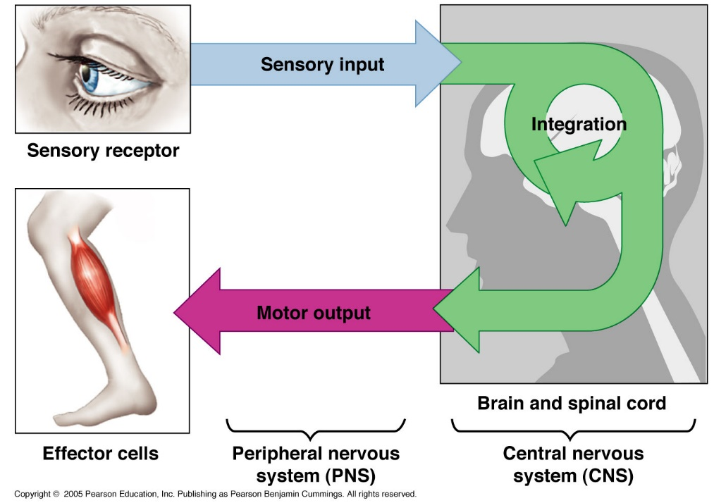

- Where would you place the cerebrum in this image?

- Which process of the image did you implicitly refer to in your definition?

- Why was this definition incomplete?

- With the above image try to make a new definition of what is the cerebrum
The cerebrum is, one part of the nervous system which _____________, ____________________ and _________________

3 According to what you have learnt in activity 1, say if these sentences are true or false and correct the false ones.
The encephalon belongs to the CNS because it is in charge of detecting external signals.
The CNS is the encephalon
The CNS is the encephalon plus the spinal cord
The brain belongs to the encephalon but it is not just the same
The encephalon is a synonymous to name the brain
The PNS are an array of nerves that connect the CNS to the effectors (for instance, the muscles)
The sensory receptors are the eyes
4 In task 2, section 4.3 you had a look to the lateral perspective of the encephalon
- Try to match the names of the four lobes with their numbers below
Occipital Temporal Frontal Parietal
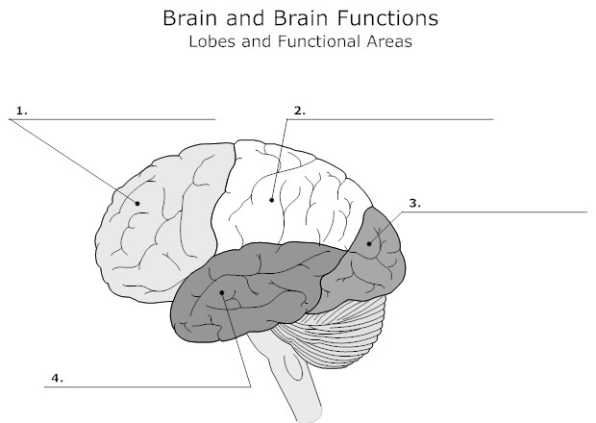
- Look at the image below, and complete the table under it:
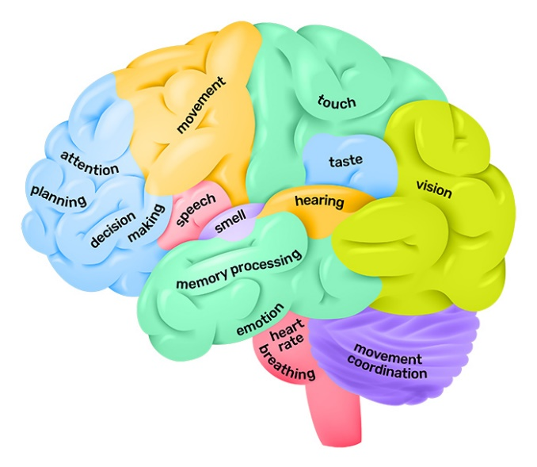
Region of the encephalon | Function/s
________ lobe

________ lobe

________ lobe

________ lobe

Cerebellum

Medulla oblongata

- With the above activities try to write an essay about the encephalon, the cerebrum, its four lobes and the functions of each region of the encephalon following this writing frame.

The encephalon has ________ regions: the _________, the __________ and the ___________.

- The __________ is responsible for the control of the heart rate, as well as _________

- The ________ is responsible for movement coordination.

- On the other hand, the ______ has four regions, also called the ________

- The _________ is the part of the brain (cerebrum) that we have on top of our face.
The _______ has several functions, among them we can distinguish ________, __________ and _____________
On the above image, the ________ is painted in _________

- At the back of the brain, we find the _______________
The principle function of the _____________ is related to _____________
On the above image, the ___________ is painted in ____________

- The ________ is the lobe that can be found along the lateral perspective

The ___________ has many functions, such as __________, __________, _____________, __________ and __________

On the above image, we can see that there are different colours for the _____: __________, ___________, ___________ and ___________

- Finally, around the ear, it is found the __________.

The ___________ is in charge of ___________, ___________ and ________

On the above image, the _________ is painted in ________ and in _________

- Complete the table with the expressions in bold
Expression | Translation

- Which of them are new to you? Make a list

- Which of the new ones you think you can most easily incorporate to your language in use for another activity similar to this one?

