Previous ideas about the brain and the nervous system and how it works
Maybe some of you are considering studying psichology. To start the unit we are going to do a warming up activity about some topics that concern the way the brain works.
After doing that we are going to study the nervous system from the point of view of the anatomy and the phisiology .
If we have time, at the end of the unit we are going to introduce some concepts of neuroscience to approach the psychological perspective, so we may come back to some of these cartoons after that and analyse them from the light of the concepts we will have been working on.
Look at the following cartoons extracted from https://www.cartoonstock.com/sitesearch.asp?categories=All+Categories&artists=All+Artists&mainArchive=mainArchive&newsCartoon=newsCartoon&vintage=vintage&searchBoxButton=SEARCH&ANDkeyword=neurology&cp=3 and answer them in small groups, we will then discuss them with the whole class after doing that.
Cartoon 1 Telepathy
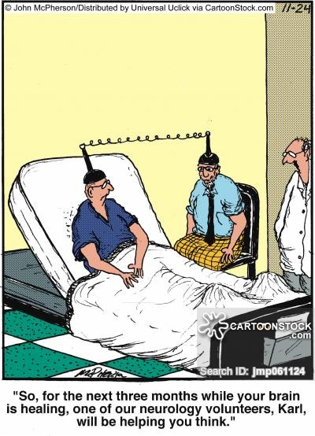

- Do you believe in telepathy?

- Did you have some experiences of telepathy? Tell us

- Which evidences do you have that telepathy is something real?

Cartoon 2 Stimulation of the nervous system via education and games
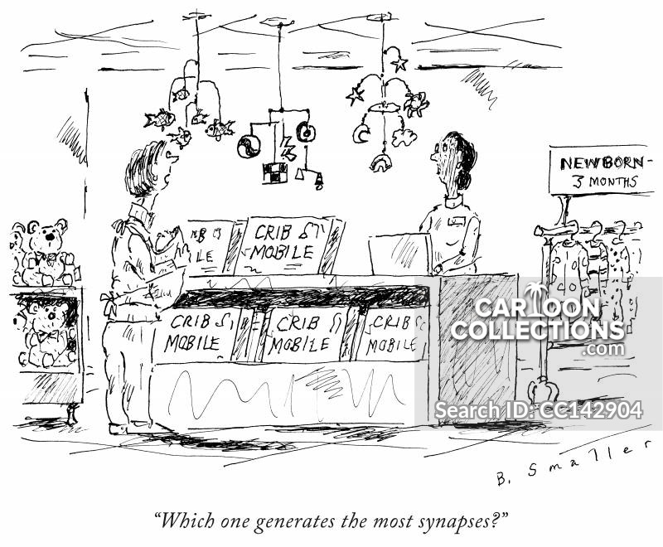
- Would you agree that educational or game stimulation promotes the development of the brain?

- Do you think that the type of crib mobile in the picture would make any difference? Why? Say two reasons to justify your answer.

Cartoon 3 The brain determines my behaviour or just influences me
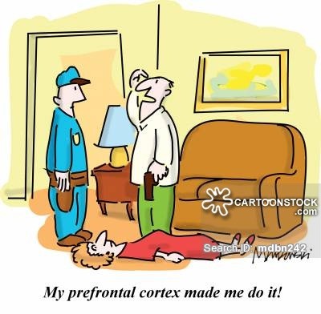
- Surely sometimes you have heard unfortune news about murders or crimes committed by people that when taken into court plead insanity to justify their acts. Do you think that certain people can be right when they plead so? Give reasons for your answer.

- Do you think that this is always the case (put yourself in the opposite situation that you defended before) by using the title of cartoon 3 ( the brain determines or influences). Try to explain this other view.

Cartoon 4 Knowledge is transferable from one person to another
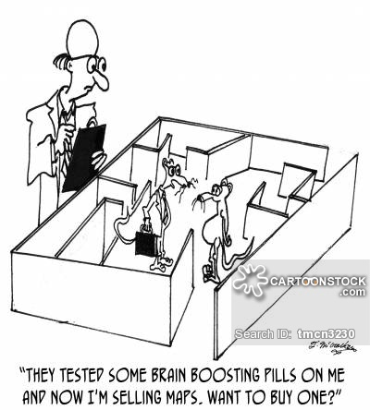
- If mouse A had to learn how to find the cheese in the maze, do you think he can show mouse B how to reach it skipping the steps that mouse A did to get to the solution? Why?

- If you do not agree with your mates give reasons to defend your view.

Cartoon 5 Symbolic thinking
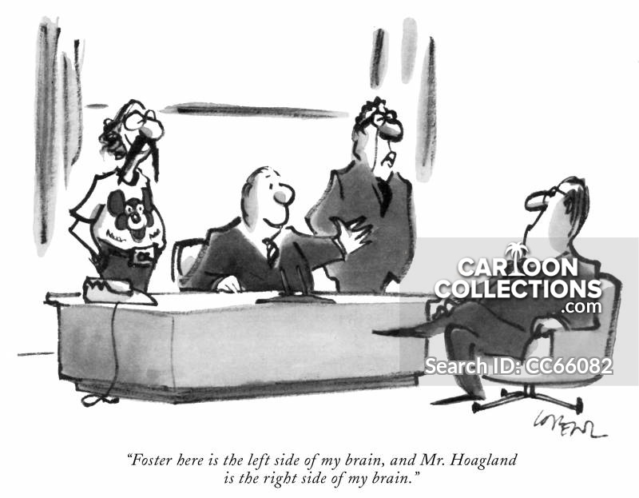
- What does the speaker mean, when he says that the man that it’s on his left is ‘his left brain’?

- What does the speaker mean, when he says that the man that it’s on his right is ‘his right brain’?

- Had you heard about the difference between the two hemispheres before?

- If everyone has a left and a right brain, what do you think, one individual has an inclination to become a certain professional or there are other reasons that make him get inclined to become one thing or another? Justify your answer.

Cartoon 6 The way of thinking
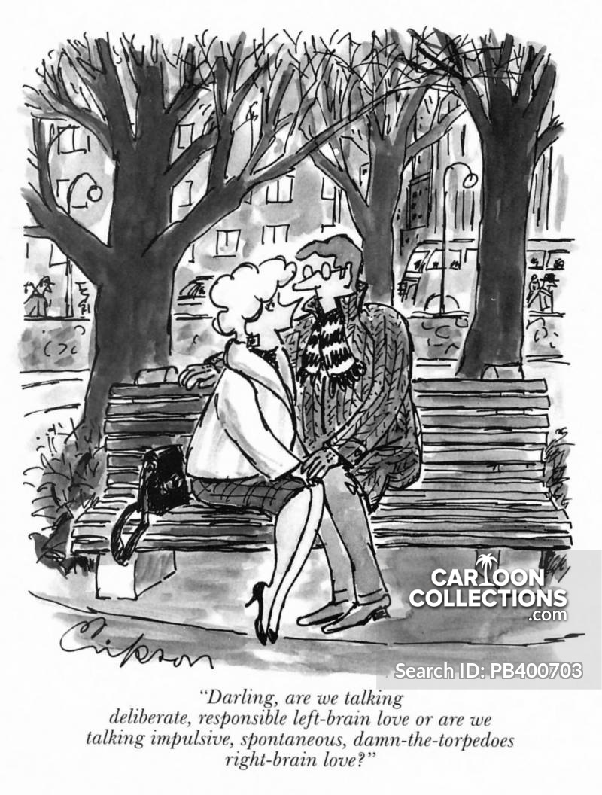
- Would you say that the woman on the picture talks spontaneously or you’d rather say that she is analytical?

- Which hemisphere of the brain is she using when she speaks like that?

Cartoon 7: Memory along lifespan
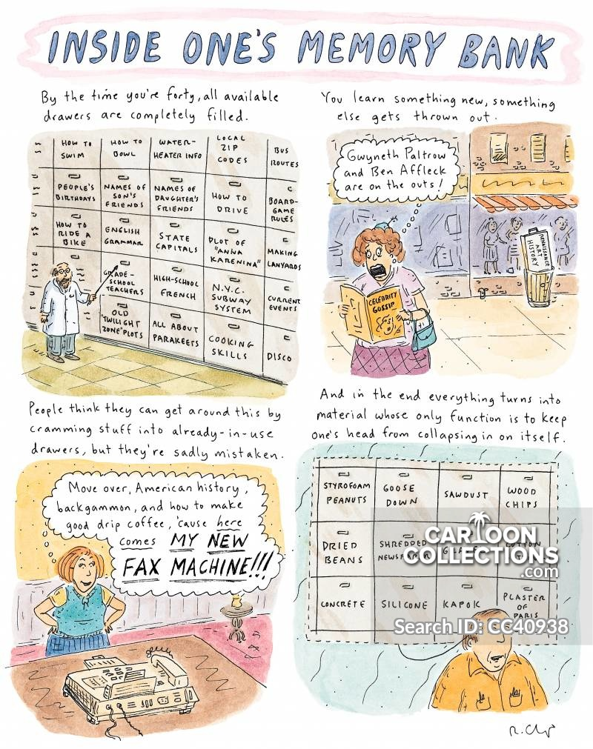
- Do you think that information on your brain is organized in separate places?

- Do you think that these places are closed containers or they can relate one to another?

- Do you agree that when you reach a certain age you cannot learn anything else? Justify your answer?
- Do you agree that when you learn something new that makes you forgot another thing or there are other reasons to explain that, which wants would them be (if that is your opinion)?

Cartoon 8 The capacity of the brain and the real usage we give to it
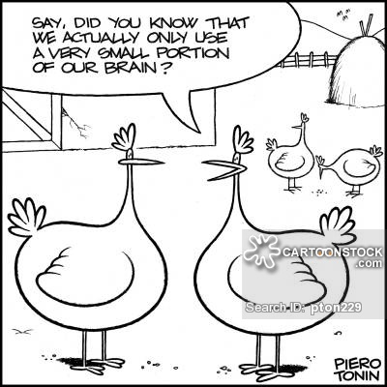

- Surely you may have heard about this sentence. Do you think it’s right or wrong? Why?

- What does the brain usage depend on?

